Gated Housing Development
LAND LOTS FOR SALE
From 10,000 S.F. @ $600,000.00
Contact:
Jennifer Abraham; Colin Borde; Josette Quesnel (868) 687-5615; (868) 788-5842; (868) 789-0768
Email: househunterstt@gmail.com
Website: www.househunterscaribbean.com

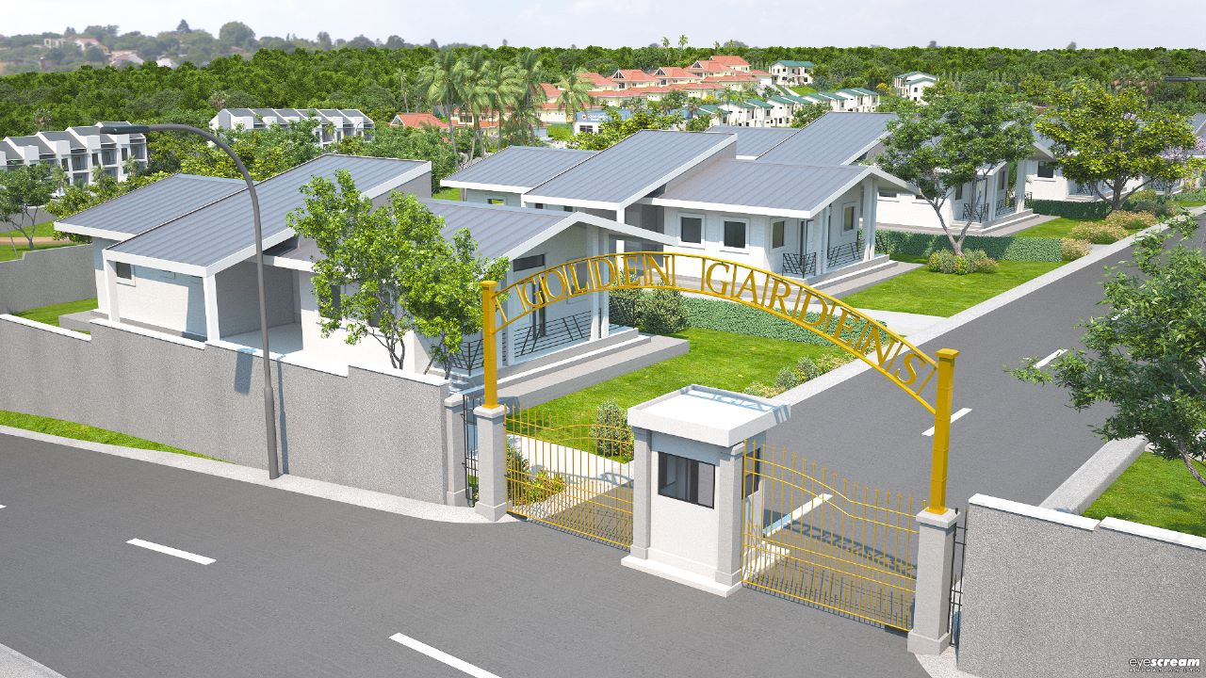
A Gated Community located on a 20 acre parcel of land in the lush green plains close to the foothills of Trinidad’s Northern Range in the burgeoning town of Valencia in close proximity to the Main Road junction intersection.
A Project of 55 freehold lots from 10,000 s.f. to 12,000 s.f. at $60.00 p.s.f. of flat land with 3 Architecturally designed houses to choose from, comes with all statutory approvals.
Golden Gardens is planned as a community oriented facility with amenities such as a Community Centre, Day Care Centre, Holistic Medical Centre and Health Care Hotel, Retail and Convenient Shops, a Recreational Park which includes the clean unpolluted river which runs through the park. These amenities are integrated to our concept of a planned Housing Development that enhances living standards and conditions for young families.
Our Master Plan concept reflects awareness for the environment whereby much of the site’s topography, its dense vegetative cover and the river is preserved. This meandering water course which traverses the northern section of the site can be explored by the adventurous as it leads to several of the best waterfalls in our Island. Entry to this incredible Housing Development is via two points east and west respectively.
Our Housing concepts are designed to satisfy the needs of families and investors looking for modern healthy living lifestyles. All 3 of our unit type designs are extremely spacious and accommodating to the modern family. Yes you can choose to build your own house, but choosing one of our Architects 3 designs which are already pre-approved and ready to be built by the Developer’s team of professionals, will save you all the hassle and trouble of doing it yourself.

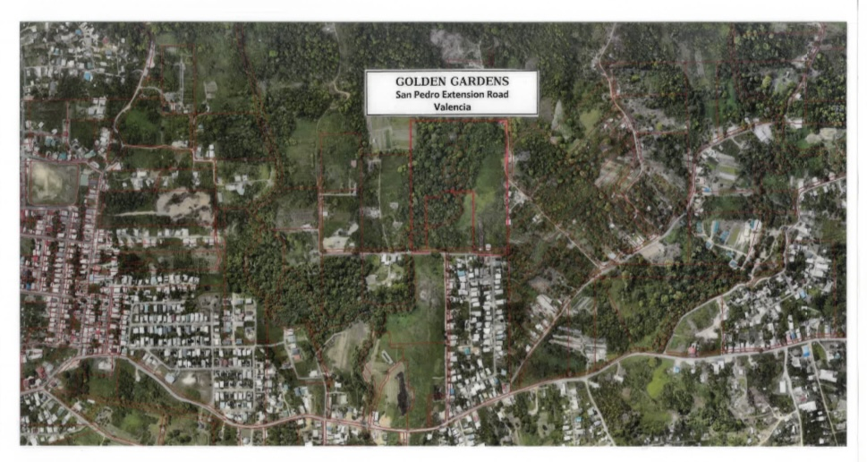

Golden Gardens is located close to the foothills of Trinidad’s Northern Range in the town of Valencia, with much to offer everyone, from newlyweds and young families to retirees and returning citizens.
Golden Gardens is a housing and healthy life initiative of the Humanitarian Institute of Health Education and Industry, an organization dedicated to the improvement of the quality of life experienced by our population.
Large housing lots will provide residents with the option of yard space where fruit tree seedlings will be offered by the developers to be planted there for future bounty.
Jogging and nature trails and ready access to an abundance of nature’s harvest of fruits, vegetables and medicinal herbs, its designers have striven to help create an environment perfectly suited for the complete enjoyment of life and health.
Based on a vision for the promotion of sustainable, healthy lifestyle, Golden Gardens is the first of its kind in Trinidad. Combining security and quality housing with beautiful ambiance, Clubhouse facilities, open air sporting facilities and jogging track.
It is indeed a blessing to be able to walk outside, breathe in the fresh air, pick fresh fruit from your own trees and bathe in clean refreshing water in the river that runs through the Golden Gardens estate.

Amenities Include:
- Wedding Venues
- Swimming Pool
- Volleyball Court
- Basketball Court
- Jogging Track
- Small Goal Football
- Wind ball Cricket
- Space Watch – nighttime planet viewing (astronomy)
- Health & Fitness Club
- Club House

Land only option:

- Land Option – Land for sale 10,000 sq.ft. and 12,000 sq.ft. lots at $60.00 per square foot.

Access:
- 2 roads access to housing development through San Pedro Extensions roads and off the Valencia Main Road, eastward.

Ancillary facilities such as the Day Care Centre, Community Centre, Retail Convenient Shops are considered for Phase II Construction. However planning consideration is provided for the future construction of a Holistic Health Care Facility focused on natural medication which will address the psychological, societal, ethical and spiritual dimensions of health and illness which is a vision of the project developers.
HOUSING SALES PRICE SCHEDULE Date: 15th May 2023

GOLDEN GARDENS
SAN PEDRO EXTENSION
VALENCIA

Model Unit | Square Footage of model units | Cost p.s.f. of model units | Land Cost (12,000 s.f. lot @ $58.00 p.s.f.) | Selling Price (land and house)
Type E  Single Storey  3 bedroom unit | 1235 s.f. | $600.00 | $695,000.00 | $1,436,000.00
Type F  Single Storey  3 bedroom unit | 1238 s.f. | $600.00 | $695,000.00 | $1,437,800.00
Type G  2 Storey  3 bedroom unit | 1270 s.f. | $700.00 | $695,000.00 | $1,584,000.00
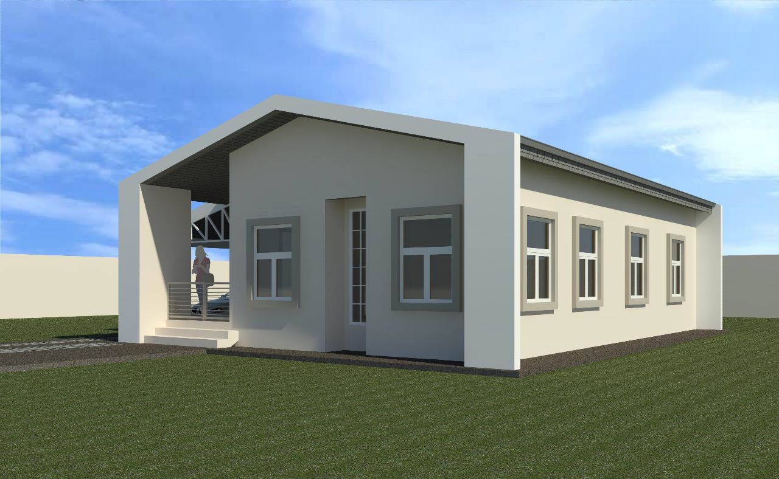
TYPE E

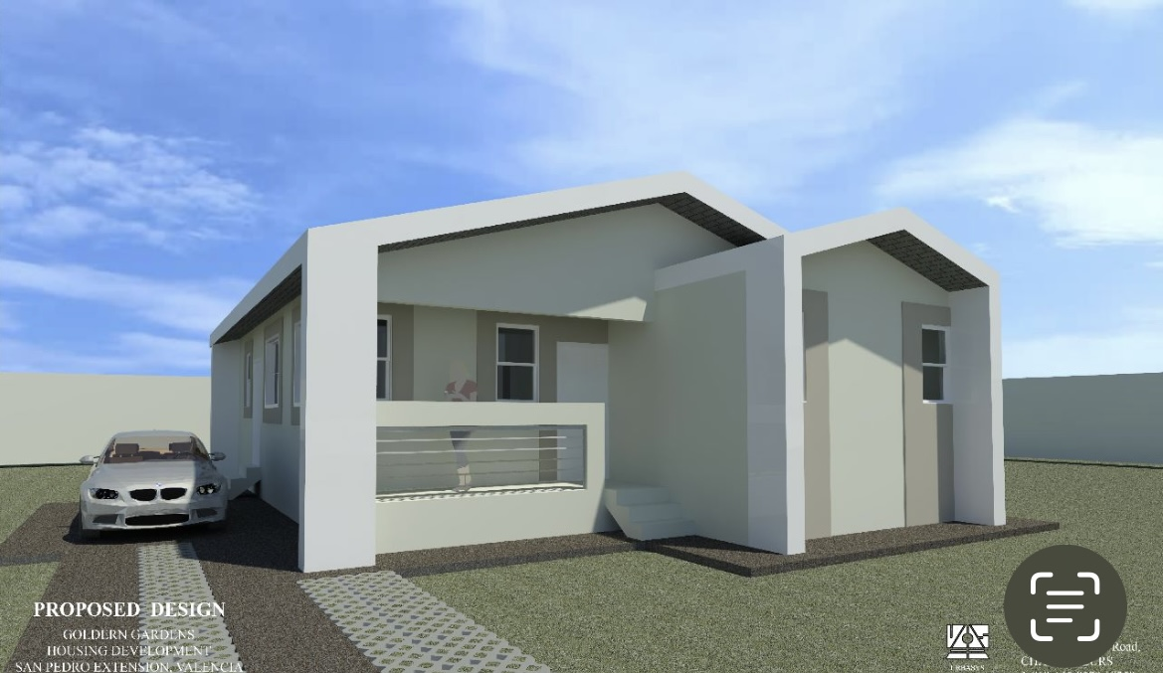
TYPE F

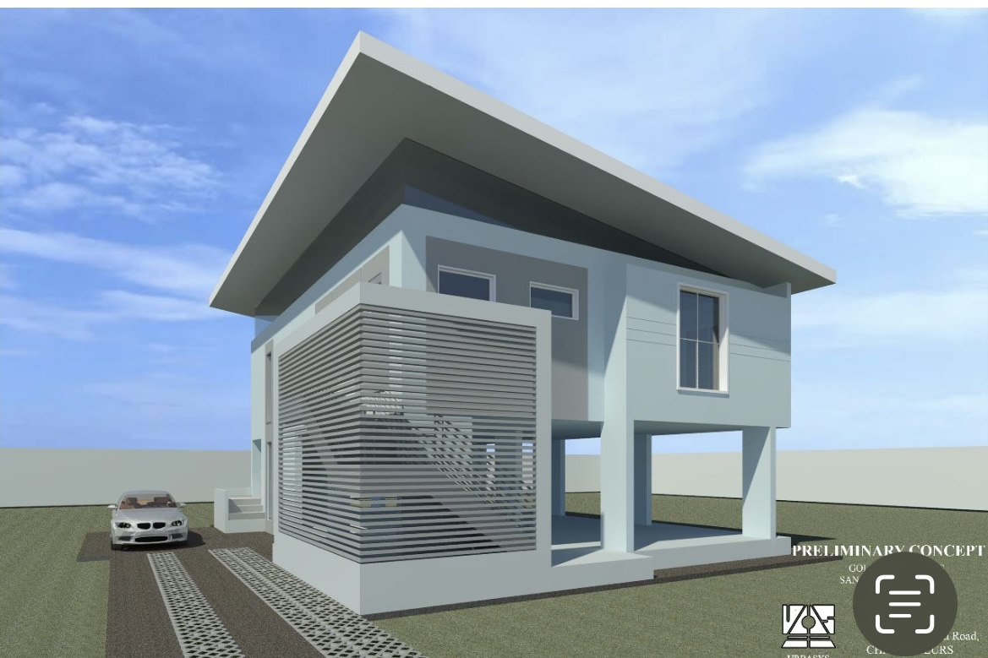
TYPE G
LAYOUT PLAN
